**Code analysis of C++ code using SonarQube and Sonar Scanner:**

**Steps to install SonarQube on local machine:**

* Download the SonarQube from https://www.sonarqube.org/downloads/ .
* Copy the downloaded file into any of the disks.
* Extract the file and go to bin folder and then into the specific OS folder and now copy the path into CMD then run the command “SonarStart”.
* Go to the browser and type localhost:9000 in url section.
* You can login into SonarQube using admin as username and admin as password for the first time. You can change the password later.

Also download the latest Sonar Scanner as below

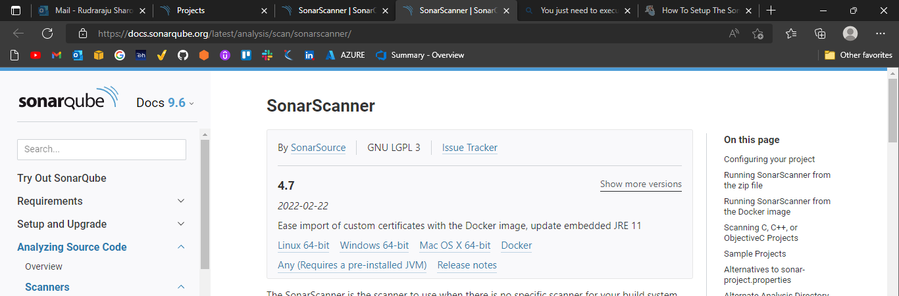

Expand the downloaded file into the directory of your choice. We'll refer to it as $install_directory in the next steps.

**In my case $install_directory= sonar-scanner-4.7.0.2747**

Update the global settings to point to your SonarQube server by editing $install_directory/conf/sonar-scanner.properties:

#----- Default SonarQube server

sonar.host.url=http://localhost:9000

Add the $install_directory/bin directory to your path.

Verify your installation by opening a new shell and executing the command sonar-scanner -h (sonar-scanner.bat -h on Windows). You should get output like this:

usage: sonar-scanner [options]

Options:

-D,--define <arg> Define property

-h,--help Display help information

-v,--version Display version information

-X,--debug Produce execution debug output

If you need more debug information, you can add one of the following to your command line: -X, --verbose, or -Dsonar.verbose=true.

Run the following command from the project base directory to launch analysis and pass your authentication token:

sonar-scanner -Dsonar.login=myAuthenticationToken

Now we have to create a project manually in SonarQube Server

Create Project Name

Create Project Key

**myAuthenticationToken:** sqp_0d27fdc1350dfb70e9071f617581de1d600ed892

Now set the sonar-scanner.properties to the following values in the following path **sonar-scanner-4.7.0.2747\conf\ sonar-scanner.properties**

# must be unique in a given SonarQube instance

sonar.projectKey=Project-123

# --- optional properties ---

# defaults to project key

sonar.projectName=Project

# defaults to 'not provided'

sonar.projectVersion=1.0

# Path is relative to the sonar-project.properties file. Defaults to .

sonar.sources=.

# Encoding of the source code. Default is default system encoding

sonar.sourceEncoding=UTF-8

#----- Default SonarQube server

sonar.host.url=http://localhost:9000

And also set the environment variable path to **sonar-scanner-4.7.0.2747\bin**

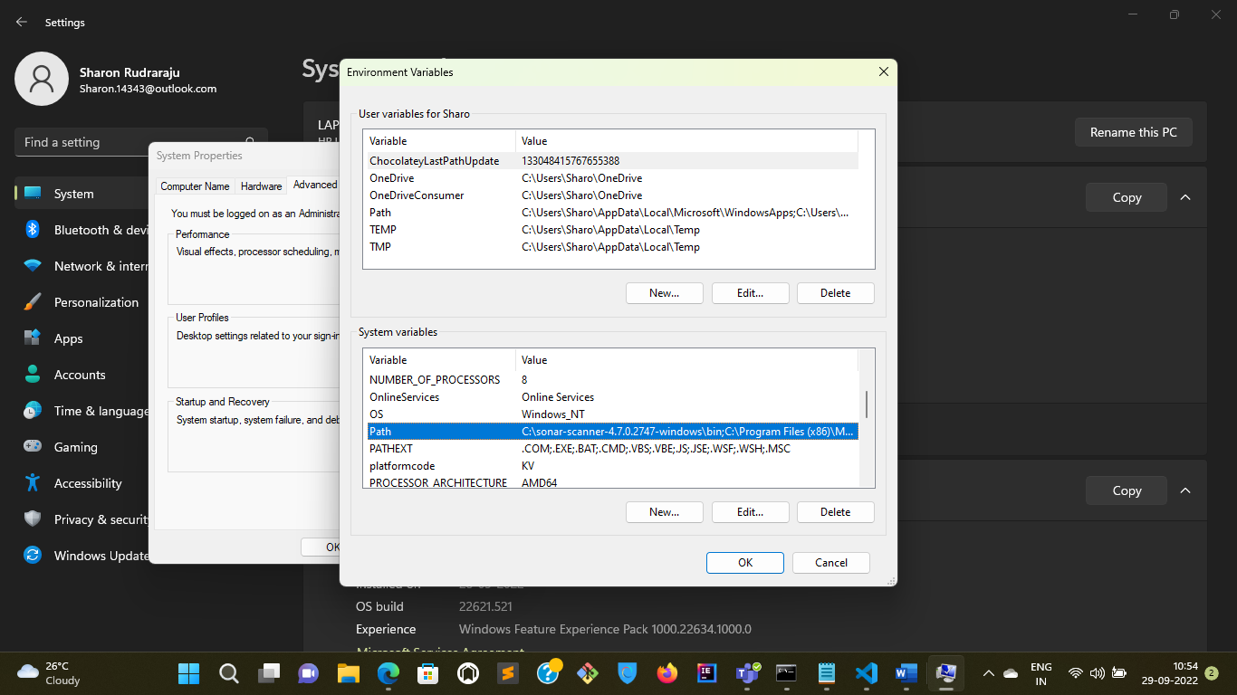

Now go the folder where your code is available and run the following command

**sonar-scanner.bat -D"sonar.projectKey=Project-123" -D"sonar.sources=." -D"sonar.host.url=http://localhost:9000" -D"sonar.login=sqp_0d27fdc1350dfb70e9071f617581de1d600ed892"**

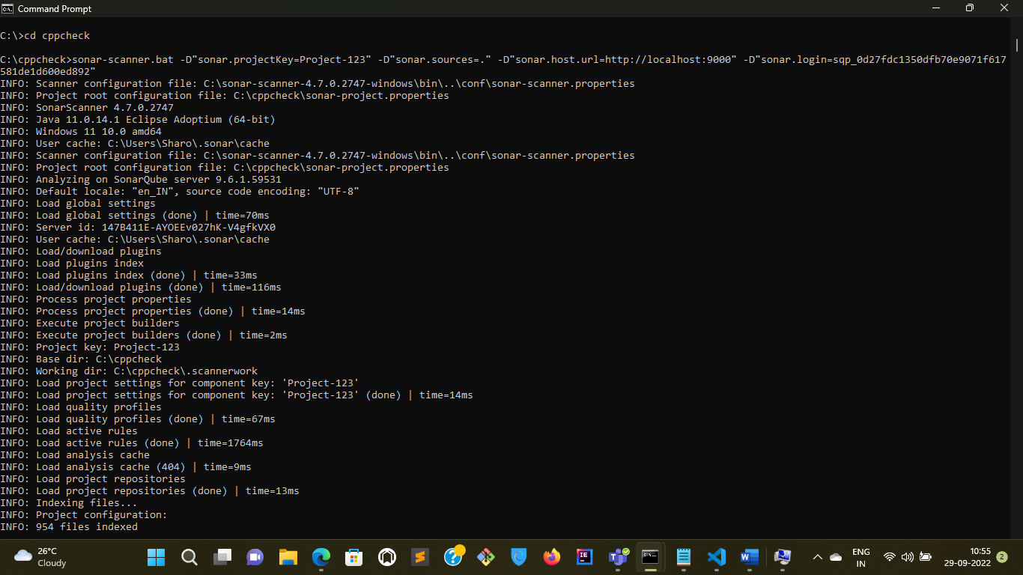

Now go and check whether the code has analysed in the SonarQube Server[**http://localhost:9000/**](http://localhost:9000/)

